**Project Design Phase-II**

**Data Flow Diagram & User Stories**

|  |  |
| --- | --- |
| Date | 31 January 2025 |
| Team ID | SWTID1743353335 |
| Project Name | Book a doctor using MERN |
| Maximum Marks | 4 Marks |

**Data Flow Diagram:**

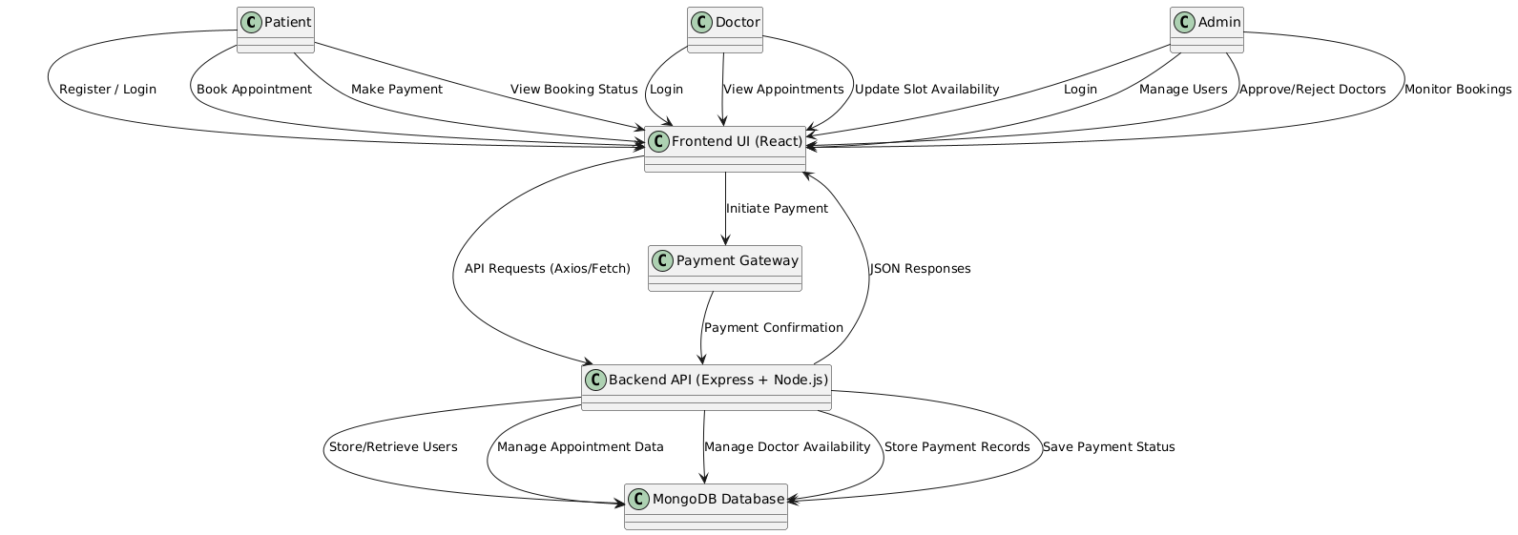

**User Stories:**

|  |  |  |  |  |  |  |
| --- | --- | --- | --- | --- | --- | --- |
| User Type | Functional Requirement (Epic) | User Story Number | User Story / Task | Acceptance Criteria | Priority | Release |
| Patient (Web user) | Registration | USN-1 | As a user, I can register for the application by entering my email, password, and confirming my password. | I can access my account/dashboard | High | Sprint-1 |
| Patient (Web user) | Registration Confirmation | USN-2 | As a user, I will receive confirmation email/OTP after registration. | I can confirm registration and activate my account | High | Sprint-1 |
| Patient (Web user) | Social Login | USN-3 | As a user, I can register via Gmail or LinkedIn. | I can register and access the dashboard using social login | Medium | Sprint-2 |
| Patient (Web user) | Login | USN-4 | As a user, I can log into the system using my email and password. | I am able to access the dashboard after login | High | Sprint-1 |
| Patient (Web user) | Appointment Booking | USN-5 | As a patient, I can search for doctors and book appointments from available slots. | I can view and confirm my booked appointments | High | Sprint-2 |
| Patient (Web user) | Payments | USN-6 | As a patient, I can pay through a payment gateway while booking an appointment. | I receive payment confirmation and appointment is confirmed | High | Sprint-2 |
| Doctor (Web user) | Login | USN-7 | As a doctor, I can log into the system securely. | I am redirected to my doctor dashboard | High | Sprint-1 |
| Doctor (Web user) | Slot Management | USN-8 | As a doctor, I can update my availability slots. | My available times are visible to patients | High | Sprint-2 |
| Doctor (Web user) | Appointment Management | USN-9 | As a doctor, I can view and manage booked appointments. | I can see a list of confirmed patient bookings | High | Sprint-2 |
| Admin (Web user) | Login | USN-10 | As an admin, I can securely log into the system. | I can access the admin dashboard | High | Sprint-1 |
| Admin (Web user) | Doctor Approval | USN-11 | As an admin, I can approve or reject doctor registration requests. | Only approved doctors are added to the system | High | Sprint-2 |
| Admin (Web user) | User Management | USN-12 | As an admin, I can manage all users (patients and doctors). | I can add, remove, or deactivate users | High | Sprint-2 |
| Admin (Web user) | Booking Monitoring | USN-13 | As an admin, I can view all appointment bookings. | I can monitor the booking activity and statistics | Medium | Sprint-2 |